The purpose of this script is to generate an Excel file from which you can quickly identify errors in the allocation of folder rights. You can use this script on any folder and run it on any computer with administrative rights.
INSTRUCTIONS
- Place the file in the location of your choice, and double-click the file called “Permissions on subfolders.vbs”.
- Select the folder that contains the subfolders you wish to analyze. For example: if you wish to know the security rights on all of the team folders, select the folder where all of the team folders are located.
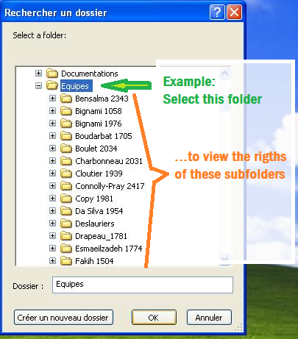

- Specify where you want the Excel report to be saved then click OK. By default, the script saves the file on C:\permissions on folders.xls but feel free to change the path or file name. If you do, don’t forget to add the .xls extension at the end of the file name.
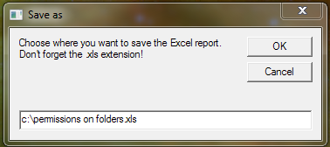
- A message will confirm the start of the operation. Click OK.
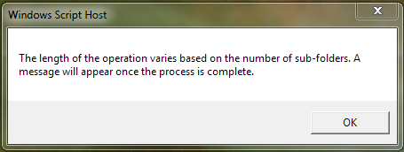

- Once the process has completed, the following message will appear reminding you the path where you can find the report and the number of folders that were processed.
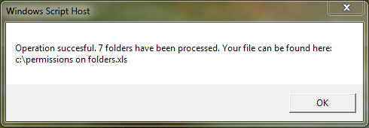
Note: if a file with the same name already exists you will be asked if you want to overwrite it.

- The report will then open automatically.
Column A: Name of Folder
Column B: Complete Access path of the folder
Column C: Authorized Users of Groups. Please note that the Domain Admins group is never listed.
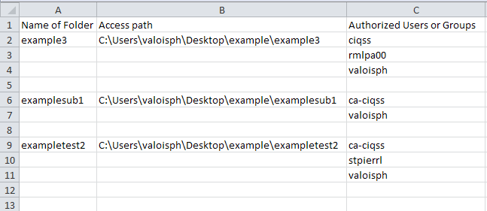
In this example, I analyzed the C:\Users\valoisph\Desktop\example\ folder.

